1. 学习中存在的问题：

有时候觉得自己代码写对了，但是得不到自己想要的结果

英语不好，有些理解比较困难，需要先查词

2.使用R进行数据处理的优势

（1）免费

（2）丰富的资源

（3）可在任何环境下运行

3.

> Num=numeric (length=4);

> Num

[1] 0 0 0 0

4..

> User_ID =9527

> as.character(User_ID )

[1] "9527"

5

> age=17;

> is_adult=age>18

> is_adult

[1] FALSE

6.

> #a

> zongshu =360;

> zushu =6;

> zuneirenshu =4;

> a1=zongshu/zushu/zuneirenshu

> a1

[1] 15

> #b

> suichang =324;

> chechang =18;

> s =suichang +chechang;

> s

[1] 342

> v =18;

> a2=s/v;

> a2

[1] 19

> #c

> day=7;

> sum1=4515;

> sum2=1155;

> chazhi=sum1-sum2;

> a3=chazhi/day;

> a3

[1] 480

> #d

> chang1=12;

> bianchangcha=2;

> kuan1=8;

> chang2=chang1+bianchangcha;

> kuan2=kuan1+bianchangcha;

> s1=chang1*kuan1;

> s2=chang2*kuan2;

> a4=s2-s1;

> a4

[1] 44

> answer =c(a1,a2,a3,a4)

> answer

[1] 15 19 480 44

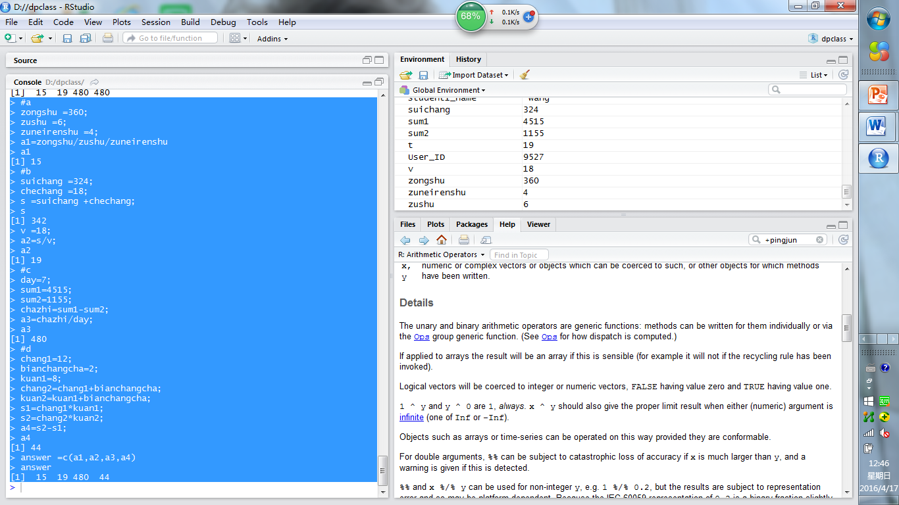

7．

> result=seq(2,14,by=3)

> result

[1] 2 5 8 11 14

8

> names =c("zhangsan","lisi","wangwu");

> height =c(165,175,170)

9.

> user.data=data.frame(names,height)

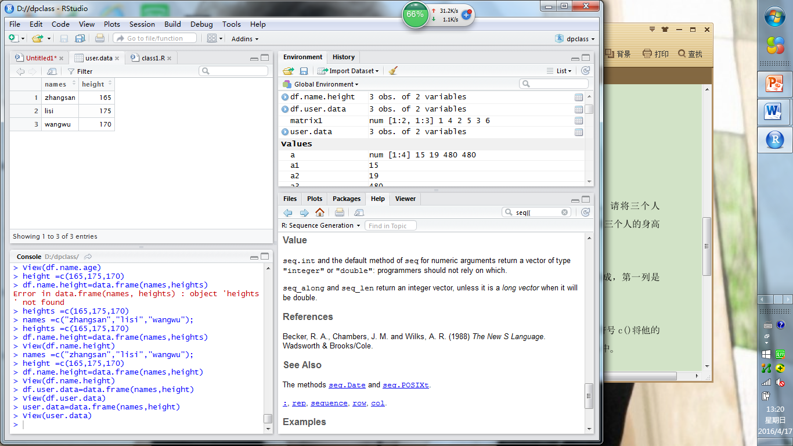

10.

> names1=c(names,"xiaoming")

> height1=c(height,"180")

> names =names1

> height =height1

> user.data=data.frame(names,height)

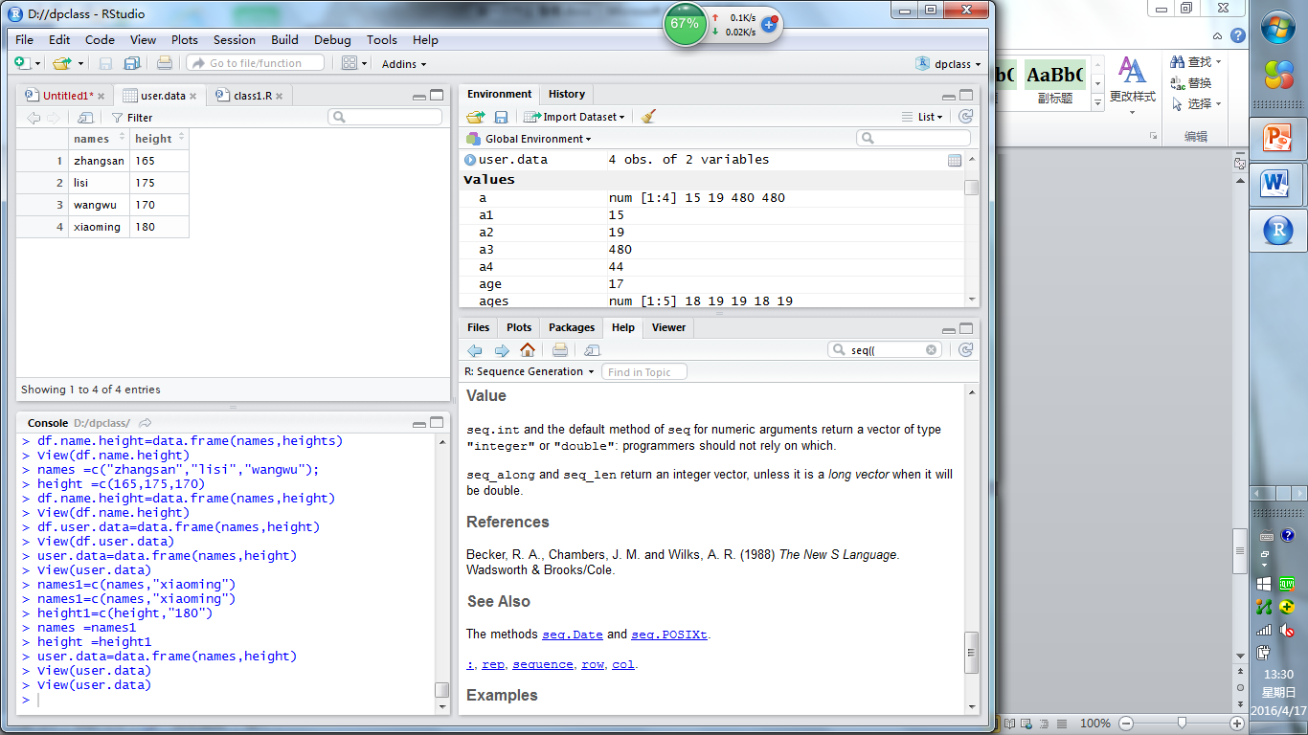

11.

> for(i in 1:4)

+ {if(height[i]>=170)

+ {print(names[i])}

+ }

[1] "lisi"

[1] "wangwu"

[1] "xiaoming"

12

> weight =c(55,65,70,80)

> cbind(user.data,weight)

names height weight

1 zhangsan 165 55

2 lisi 175 65

3 wangwu 170 70

4 xiaoming 180 80

> user.data=cbind(user.data,weight)

> View(user.data)

